**Lab Report. 01**

**Subject: Computer Graphics Lab**



Submitted to: Dr. Junaid

Submitted by: Nayab Ashraf (RC-299)

**Date of Submission: 11 September, 2024**

National University of Modern Languages, Department of Computer Science, Rawalpindi Campus.

**Code**

#include<windows.h>

#include <GL/gl.h>

#include <gl/glut.h>

void myInit()

{

glClearColor(1.0, 1.0, 1.0, 0.0);

glPointSize(10.0);

glMatrixMode(GL_MODELVIEW);

glLoadIdentity();

gluOrtho2D(0.0, 500.0, 0.0, 500.0);

}

void Display()

{

glClear(GL_COLOR_BUFFER_BIT);

glColor3f(1.0, 0.0, 0.0);

glBegin(GL_POINTS);

glVertex2f(50.0, 100.0);

glEnd();

glFlush();

}

int main(int argc, char** argv)

{

glutInit(&argc, argv);

glutInitDisplayMode(GLUT_SINGLE);

glutInitWindowSize(500, 500);

glutInitWindowPosition(0, 0);

glutCreateWindow("First Graphic Code");

myInit();

glutDisplayFunc(Display);

glutMainLoop();

}

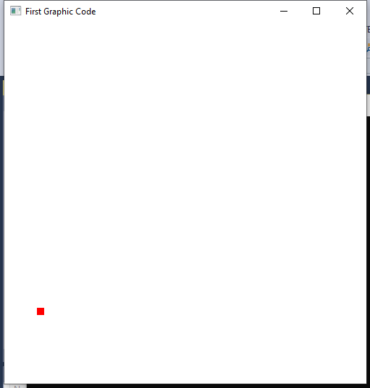

**Task 01:**

Change the background colors (atleast 3 different).

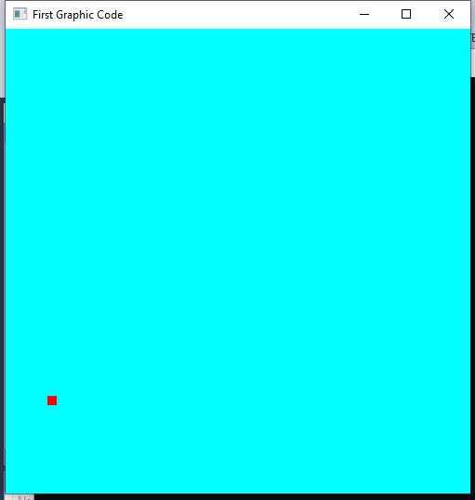

glClearColor(0.0, 1.0, 1.0, 0.0);

The line glClearColor(0.0, 1.0, 1.0, 0.0); sets the background color to cyan (green + blue) in our OpenGL window.

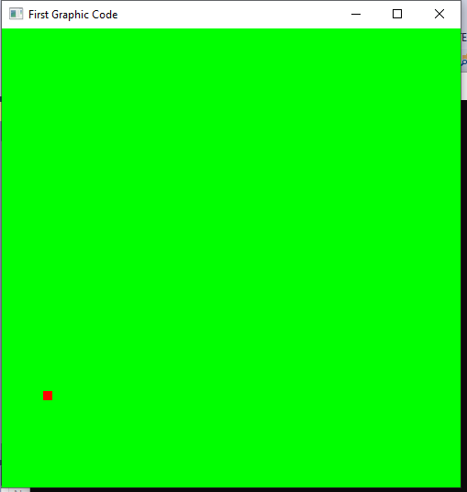

glClearColor(0.0, 1.0, 0.0, 0.0);

The line glClearColor(0.0, 1.0, 0.0, 0.0); sets the background color to green in our OpenGL window.

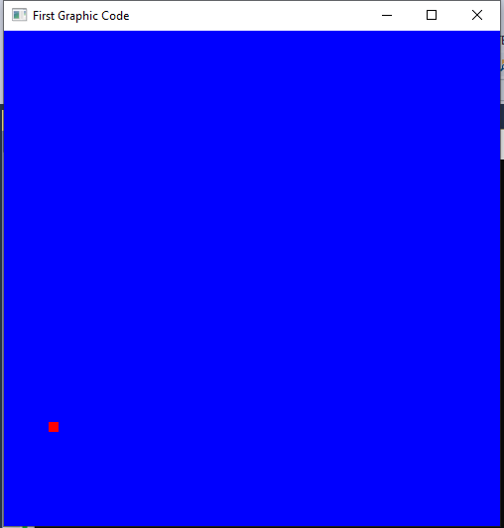

glClearColor(0.0, 0.0, 1.0, 0.0);

The line glClearColor(0.0, 0.0, 1.0, 0.0); sets the background color to cyan (green + blue) in our OpenGL window.

**Task 02:**

Change the point size.

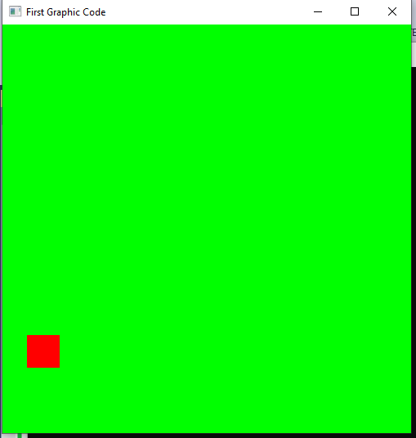

glPointSize(40.0);

The line sets the glPointSize(40.0) point size to 40 in our OpenGL window.

**Task 03:**

Change the point location.

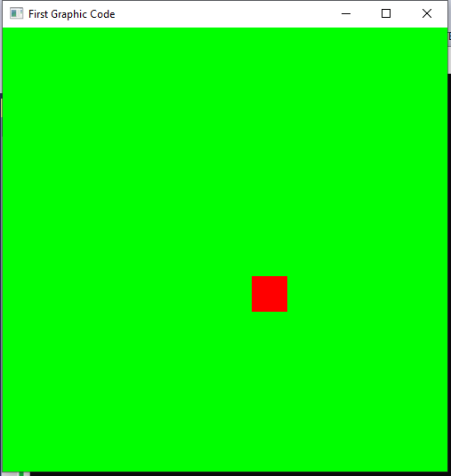

glVertex2f(300.0, 200.0);

The line sets the glVertex2f(300.0, 200.0) point location in our OpenGL window.

**Task 04:**

Create any shape with the help of these dots.

#include<windows.h>

#include <GL/gl.h>

#include <gl/glut.h>

void myInit()

{

glClearColor(1.0, 1.0, 1.0, 0.0);

glPointSize(40.0);

glMatrixMode(GL_MODELVIEW);

glLoadIdentity();

gluOrtho2D(0.0, 500.0, 0.0, 500.0);

}

void Display()

{

glClear(GL_COLOR_BUFFER_BIT);

glLineWidth(5);

glColor3f(1.0, 0.0, 0.0);

glBegin(GL_LINES);

glVertex2f(50.0, 100.0);

glVertex2f(300.0, 100.0);

glVertex2f(50.0, 100.0);

glVertex2f(50.0, 300.0);

glVertex2f(300.0, 100.0);

glVertex2f(300.0, 300.0);

glVertex2f(300.0, 300.0);

glVertex2f(175.0, 400.0);

glVertex2f(50.0, 300.0);

glVertex2f(175.0, 400.0);

glVertex2f(100.0, 100.0);

glVertex2f(100.0, 200.0);

glVertex2f(100.0, 200.0);

glVertex2f(200.0, 200.0);

glVertex2f(200.0, 100.0);

glVertex2f(200.0, 200.0);

glEnd();

glFlush();

}

int main(int argc, char** argv)

{

glutInit(&argc, argv);

glutInitDisplayMode(GLUT_SINGLE);

glutInitWindowSize(500, 500);

glutInitWindowPosition(0, 0);

glutCreateWindow("First Graphic Code");

myInit();

glutDisplayFunc(Display);

glutMainLoop();

}

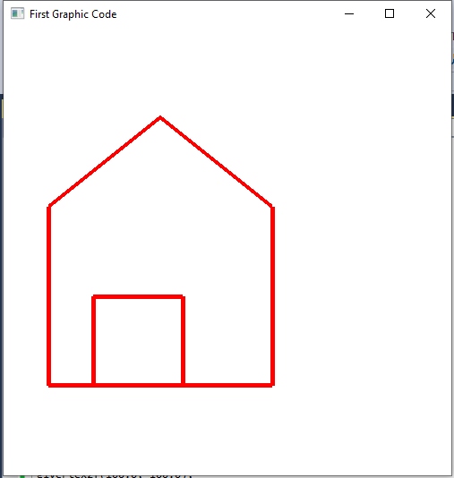

This code creates a graphics window using OpenGL and GLUT. It initializes a white background and sets up the view. The Display function draws a series of red lines to form geometric shapes. The main function initializes GLUT, creates a window, and starts the main event loop.